CEG 4166 – Real-Time Systems Design
Laboratory 3: Real-Time Object Detection and Keyboard Control of the Stingray Robot

Winter 2025
University of Ottawa
Faculty of Engineering, School of Electrical Engineering and Computer Science
Section 2
TAs: Devansh Kumar, Kamran Gholizadeh Hamlabadi

Group 9
Stingray 15
Team Members:
Keith Tran – 300240028 – ktran033@uottawa.ca
Kevin Dang – 300241133 – kdang038@uottawa.ca
Saurav Guduru – 300234999 – sgudu104@uottawa.ca

Submission Date: 2025-03-10
Table of Contents
Introduction 3
Objectives 3
Background Material 3
Functionality Scope 3
Theory 4
Real World Modelling 4
Control Principles 4
Programming Concepts 4
Experimental Setup 5
Hardware Architecture 5
Software Architecture 5
Testing Methodology 6
Results and Observation 6
Discussion 6
Challenges 6
Solutions 7
Results 7
Future Recommendations 8

Introduction

Objectives
The objectives of the laboratory are as follows:
- Expand keyboard control, with more functions mapped to keys
- Create a module to plot various data on multiple graphs
- Implement an ML-based object detection program

Background Material
This lab builds upon the previous lab by plotting graphs for the various servos on the robot, as well as implementing a machine learning model for visual object detection. This allows the robot to identify specific objects and potential obstacles, like how autonomous vehicles need to identify key objects on the road, such as pedestrians, stop signs, and other vehicles.

Functionality Scope
The functionality to be implemented for this lab are as follows:
Plotting multiple graphs: movement data on the various servos of the robot are plotted in real time
Object-detection system: an AI model can view the camera feed and identify certain objects
Name and number display: student names and numbers are shown on the display screen
Direct user control: keyboard inputs can control the robot’s movement, camera, and sensors

Theory

Real World Modelling
For this lab, real world modelling was performed through the implementation of the object detection algorithm while controlling its movement with the keyboard which allows the stingray to respond to real world stimuli. The object detection algorithm was modeled using OpenCV and TensorFlow, allowing the stingray to identify and classify nearby objects. Additionally, the plots we are creating with the sensor data provides us with insight on how the sensor is collecting and processing the data to process its environment.

Control Principles
The control principles used in this lab consisted of real-time control and feedback loops in addition to the PID controller from the previous lab. The stingray’s behaviour comes from the data collected by the camera and sensors which gives it real time information of its surroundings. The key part of this lab is the obstacle avoidance which it uses the sonar data to detect obstacles and adjusts its path in real time while being controlled by the keyboard. This is done through multi-threading, which allows us to handle multiple tasks simultaneously allowing for the stingray to move accurately and efficiently.

Programming Concepts
The following are the important programming concepts used in this lab.
Multithreading and concurrency: the different functions of the robot were executed on separate threads that ran concurrently.
Object-oriented programming: subsystems of the robot (e.g. wheel movement, sensor, camera) were virtualized as objects in the code, each with their own attributes and functions and instantiated in one shared main running program.
Use of packages: python packages were imported to make use of external tools and libraries in our code. Packages were included to plot graphs, implement multithreading, and interact with the Raspberry Pi’s GPIO interface.
Responding to user input: the robot’s program implemented direct user control over the robot’s functionality via keyboard.
Machine learning model: using the camera feed, a machine learning model using TensorFlow detects and identifies objects.

Experimental Setup

Hardware Architecture
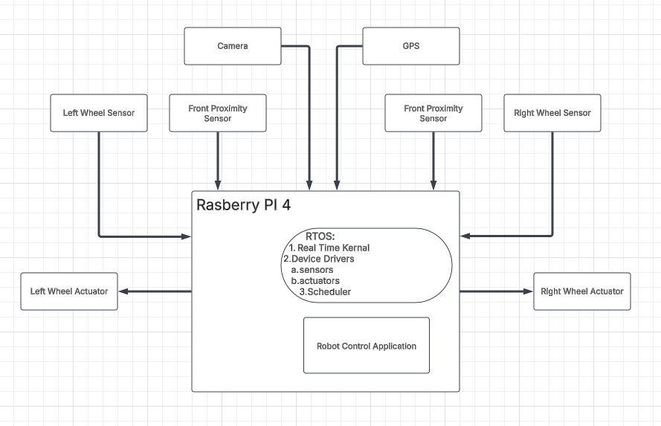

Software Architecture
The software architecture is comprised of the following program modules:
- KeyboardGPIO.py: defines the keyboard controls, with mapping of keys to specific functions of the robot
- PID.py: a virtualization of the PID controller
- PlotDataRobot_Lab3.py: plots the data concerning the robot’s movement on a graph
- WheelEncoderGPIO.py: defines the encoding for the wheel servos
- CameraGPIO.py: defines the camera component of the robot
- UltrasonicGPIO.py: defines the graphical user interface displayed on the robot
- Object_detection.py: defines the machine learning model responsible for detecting and classifying objects via the PiCamera
- StudentNumberFlash.py: a program that sequentially displays student names and numbers on the Pi’s display screen
- Lab3.py: the main method of the software; combines all individual modules into one cohesive running program

Testing Methodology
Our methodology for testing was to first test individual components of the program at a time, then gradually test components together, before testing all the components running under one program. This was done by commenting out atomic modules of the code that were not immediately related to the specific function currently being tested.
For testing the camera and computer vision model running with TensorFlow, we tested the model’s ability to correctly detect and identify objects by placing various objects in its camera view. We found that it’s database of known objects was very limited, misidentifying many common objects such as cellphones or computer monitors; however, in many cases its estimate was very close (e.g. predicting a computer monitor as a TV). Despite this, we found that the model excelled at correctly detecting and identifying people, even when only parts of the body were shown, like the feet or hands.

Results and Observation
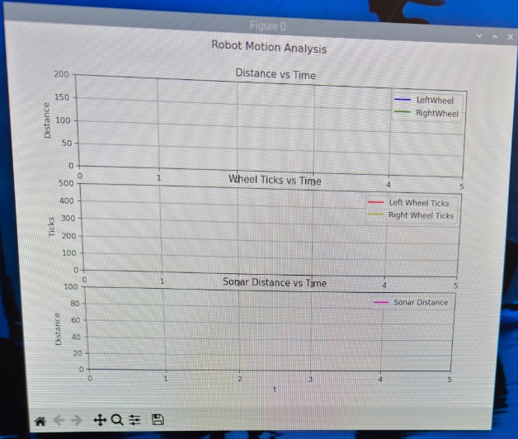
The source code for this lab can be found zipped in the file titled the following: “CEG4166_2025W_Section2_Group9_Lab3_Code_20250310-01.zip.”

Discussion

Challenges
In this lab, a key issue we ran into was a tight schedule for completing the lab deliverables. The task of integrating the machine learning model to be compatible with the PiCamera was complex and time-consuming. Additionally, installing all the required libraries and packages using the campus network on the Raspberry Pi4 would also take a long time. Having only two lab sessions meant that time was a very limited resource in this lab.
The code provided for the object_detection.py used an older version of picamera, causing it to not work with the latest picamera2 library. We tried various test code provided at the end of the lab2 document as well for the camera, and that was not functional as well. There were a lot of compatibility issues regarding the libraries we encountered while running this code out of the box.
Another challenge we ran into was with the WheelEncoderGPIO.py file. To make more progress for the lab, we connected our Sd card into another raspberry pi four that we owned. This allowed us to make progress on the code and install the libraries so that we would be ready for the next session of the lab. Prior to this lab we had no errors with the WheelEncoderGPIO.py file, however, when the Sd card was brought back for the next session, we ran into an error stating that “RuntimeError: Failed to add edge detection”. Although we ran our main python file with sudo permission we still ran into errors, and we tried all the online trouble shooting methods as well, but the error persisted.

Solutions
To save time, we completed some of the work outside of the lab sessions; specifically, work that did not require direct use of the robot. For instance, downloading and installing all the required packages onto the microSD card at home not only allowed more time to be dedicated to other tasks during the lab, but it also ran much faster using a private network.
The object_detection.py file required us to rewrite the code so that the camera feed is captured appropriately for the model to detect objects. We used reference code from picamera2’s GitHub to understand how the camera feed is captured using the updated libraries. Once we had a general idea, we reworked the Video_PiCamera class to initialize the camera, update the feed, read, and stop the feed with our finding from picamera2’s GitHub.
The “RuntimeError: Failed to add edge detection” error occurred once while we were running the code on our own raspberry pi, however, when we ran our code with sudo permissions that prevented the error. We thought the same methodology would work when we encountered the error on stingray, but that was not the case. Some online forums indicated that the GPIO might be in use already which prevents the system from adding the “falling edge detection”, we ran commands like “pinout”, “gpio readall”, and we tried to stop the pigpiod daemon and restart it as well. But none of these commands helped us identify the solution to this problem. We also tried to experiment with the code, and we found that when the “add edge detect” line is commented out, the code runs and the wheels are able to move with the right commands.

Results
Overall, the results obtained matched the results that were to be expected. The computer vision model was able to run on the Raspberry Pi4 using the PiCamera, and successfully identified and classified objects detected in the camera. The expanded keyboard controls also worked in accordance with the lab manual. The graphs plotting the rotational speeds, while able to be displayed, were unable to receive the real-time data from the servos and thus were not able to accurately plot their rotational speeds.

Future Recommendations
One recommendation for performing this lab in the future would be to maximize efficiency and make use of our time in the labs. Seeing as how these are the only times windows we get to work with the physical robot, it is best that all tasks that can be done without the robot should be done before/outside the lab sessions. Hence, it is recommended that the lab manual be thoroughly read and understood before starting the lab. Not only do we save time in the lab, but it ensures that we fully understand what is required by the lab when we start working on it.

